**INDIAN INSTITUTE OF TECHNOLOGY, BOMBAY**

**Department of Metallurgical Engineering and Materials Science**

**MM 204 : TRANSPORT PHENOMENA : 2019-20 SPRING**

**Assignment 1 Submit: Jan 17; 2020; 0830h**

**NOTE : 1. Solve this assignment on your own. No, internet, no chat, no discussion with others. Short answers will do.**

**2. Submit both hard copy (in A4 size sheets, hand-written on both sides) and soft copy.**

**3. Stick to the deadline. NO postponements.**

**4. Each submission is expected to be UNIQUE !! [ Read the ground rules again]**

------------------------------------------------------------------------------------------------------------------------------------

1. 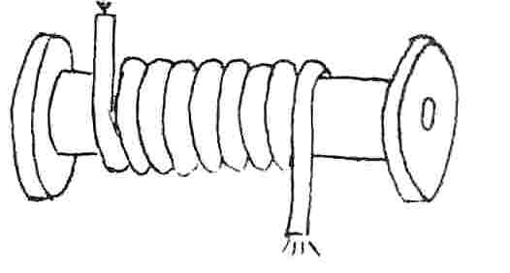If you try to *pour* water into a coiled hose as shown, no water will come out of the other end. Why ? (You should not connect it to a tap). [J.Walker]
2. There is a famous problem about throwing a stone from a boat in the swimming pool where the boat is floating. When the stone is thrown from the boat, does the water level rise fall or remain unchanged in the pool ? [J.Walker]
3. 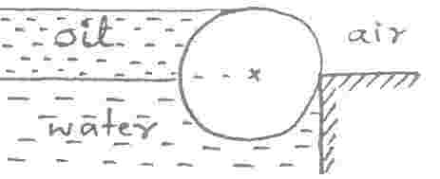A log of 0.3m diam. holds water and oil as shown. Is its density higher, lower or the same as that of water ? [WWWR]
4. 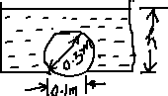In my farm house in the village (where we intend to settle down after retirement), I have an old tank in which a 0.1m round hole has been drilled for some purpose. I would now like to use it for simple storage and want the hole closed. People tell me that all I need is a beach ball and it will act nicely like a plug, as long as I take some precautions. How can this be true? What precautions? [WWWR]
5. 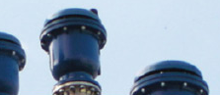On long water pipelines one finds some kind of device like shown in the figure ( you can see some of them on the large water pipes of BMC behind hostel 3 /4). They seem to be unattended, and do not have any lever/wheel to operate them (passive devices). Do you know what they are doing there?
6. In some of the house hold taps, water sometimes slows down even when the valve is fully open. At other times they run full. This often happens when the pipes are refilled after they run dry, but this is not a necessary condition. Can you tell why? Is it due to faulty plumbing ? ( may be related to problem 6). In a related issue, water from a tap sometimes looks milky white when filled in a glass. After some time water in the glass becomes clear.

1. In base ball one can throw a curve ball, a ball which swings through the air and foxes the batter. This is done in cricket and football too. How does the ball swing? Can the ball travel too fast for it to swing ?

**Fluid flow all around you, eh!**